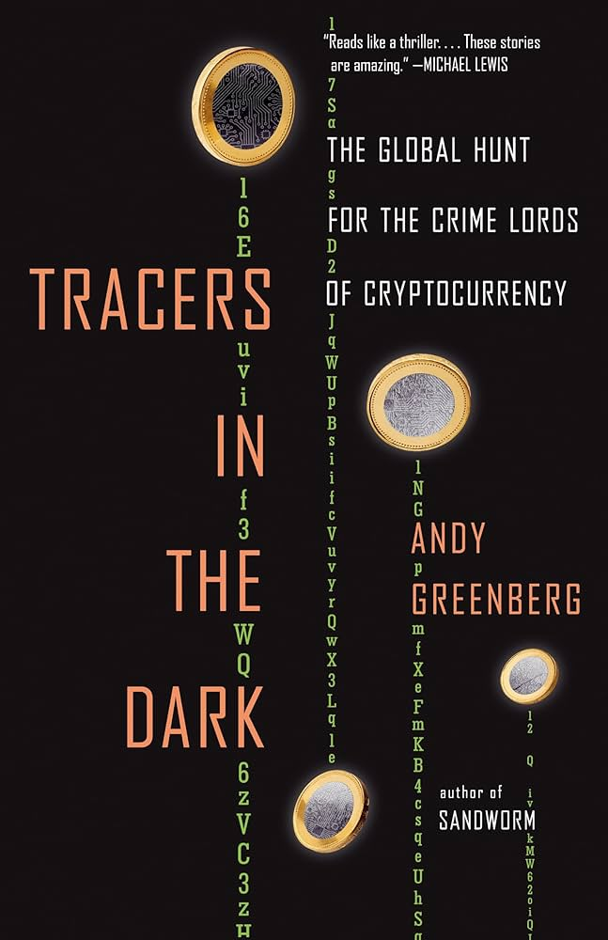
| Tracers in the Dark |
In Tracers in the Dark, Andy Greenberg takes us on a thrilling journey through the world of cryptocurrency and the hidden web of cybercrime that uses it. The book follows the rise of blockchain technology and how criminals quickly realized the potential for laundering money and hiding their tracks behind cryptocurrencies like Bitcoin. Greenberg chronicles the efforts of law enforcement agencies, hackers, and investigators working to trace these dark transactions and bring criminals to justice. What makes this story so compelling is not just the technology itself, but the human chase for truth in a world designed for anonymity.
| My Impressions |
What I found fascinating in Tracers in the Dark was how cryptocurrency, once seen as a tool for financial freedom, has turned into a haven for illicit activity. The idea that these supposedly "anonymous" transactions can be traced and decoded by investigators is both surprising and impressive. Greenberg does a fantastic job showing how complex, but possible, it is to follow the digital breadcrumbs left by criminals—even when they believe they’re in the clear.
It also made me reflect on the balance between privacy and security. While it’s easy to sympathize with those who want to use cryptocurrency for legitimate reasons, the book also highlights how the anonymity it offers has been exploited by bad actors. Governments and law enforcement agencies are in a constant battle to stay ahead of cybercriminals who are always looking for new ways to obscure their tracks.
Tracers in the Dark is a fascinating read that highlights the high-stakes world of digital investigations, where the lines between criminal and law enforcement are often blurred. It’s a compelling look at how technology continues to evolve, and how the fight for justice plays out in the shadows of the internet.

